**Assignment – 2**

**Schema Design & Table Creation (DDL & DML Commands)**

**1. Define a schema for a Library Management System with the following entities:**

**- Books**

**- Authors**

**- Members**

**- Borrow_Records**

**Ans –**

**1. Entity: Authors**

|  |  |  |  |
| --- | --- | --- | --- |
| **Attribute Name** | **Data Type** | **Description** | **Constraints / Notes** |
| author_id | integer | unique identifier for the author. | **primary key** (pk) |
| first_name | varchar(100) | author's first name. | not null |
| last_name | varchar(100) | author's last name. | not null |
| birth_year | year | year of the author's birth. |  |

**2. Entity: Books**

|  |  |  |  |
| --- | --- | --- | --- |
| **Attribute Name** | **Data Type** | **Description** | **Constraints / Notes** |
| book_id | integer | unique identifier for the book. | primary key (pk) |
| title | varchar(255) | full title of the book. | not null |
| author_id | integer | links the book to its author. | foreign key (fk) referencing authors(author_id) |
| isbn | varchar(13) | international standard book number. | unique, not null |
| publication_year | year | year the book was published. |  |
| genre | varchar(50) | category or subject of the book (e.g., fiction, science, history). |  |

**3. Entity: Members**

|  |  |  |  |
| --- | --- | --- | --- |
| **Attribute Name** | **Data Type** | **Description** | **Constraints / Notes** |
| member_id | integer | unique identifier for the library member | **primary key** (pk) |
| first_name | varchar(100) | member's first name. | not null |
| last_name | varchar(100) | member's last name. | not null |
| email | varchar(150) | member's email address | unique |
| phone_no | varchar(15) | member's contact number. |  |
| join_date | date | date the member registered. | not null |

**4. Entity: Borrow_Records**

|  |  |  |  |
| --- | --- | --- | --- |
| **Attribute Name** | **Data Type** | **Description** | **Constraints / Notes** |
| record_id | integer | unique identifier for the loan record. | **primary key** (pk) |
| book_id | integer | the book that was borrowed. | **foreign key** (fk) referencing **books(book_id)**, **not null** |
| member_id | integer | the member who borrowed the book. | **foreign key** (fk) referencing **members(member_id)**, **not null** |
| borrow_date | date | date the book was borrowed. | not null |
| due_date | date | expected date for the book to be returned (e.g., 14 days after borrowing). | not null |
| return_date | date | actual date the book was returned. | **can be null** (if the book is still out) |

**Key Relationships in the Schema**

1. **Authors** and **Books**: A **One-to-Many** relationship. One author can write many books, but each book is typically associated with a single primary author in this simplified schema.
   * *Relationship is enforced by:* author_id in the Books table.
2. **Books** and **Borrow_Records**: A **One-to-Many** relationship. One book can be part of many borrow records over time.
   * *Relationship is enforced by:* book_id in the Borrow_Records table.
3. **Members** and **Borrow_Records**: A **One-to-Many** relationship. One member can have many borrow records.
   * *Relationship is enforced by:* member_id in the Borrow_Records table.

---------------------------------------------------------------------------------------------------------

**2. Write the SQL command to create a table Authors with the following fields:**

- author_id (Primary Key, INT)

- name (VARCHAR(100))

- country (VARCHAR(50)

**Ans-**mysql> create table Authors(author_id INT Primary Key, name VARCHAR(100), country VARCHAR(50));**))**

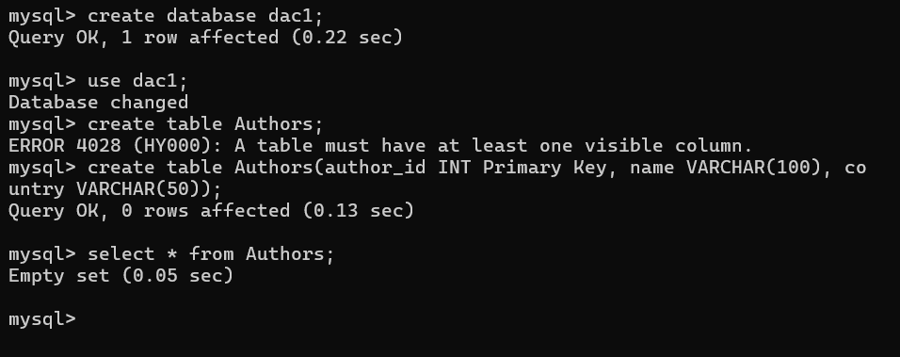

**--------------------------------------------------------------------------------------------------------**

**3. Write the SQL command to create a table Books with the following fields:**

- book_id (Primary Key, INT)

- title (VARCHAR(150))

- author_id (Foreign Key referencing Authors)

- published_year (YEAR)

- available_copies (INT)

**Ans –**

mysql> CREATE TABLE Books (

-> book_id INT PRIMARY KEY,

-> title VARCHAR(150) NOT NULL,

-> author_id INT,

-> published_year YEAR,

-> available_copies INT CHECK (available_copies >= 0),

-> FOREIGN KEY (author_id) REFERENCES Authors(author_id)

-> );

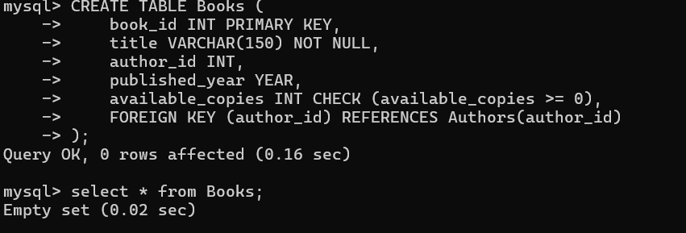

---------------------------------------------------------------------------------------------------------

**4. Write the SQL command to create a table Members with:**

- member_id (Primary Key, INT)

- name (VARCHAR(100))

- email (VARCHAR(100), unique)

- phone (VARCHAR(15))

**Ans-**

mysql> create table Members(member_id INT Primary Key,

-> name VARCHAR(100) not null,

-> email VARCHAR(100) unique not null,

-> phone VARCHAR(15));

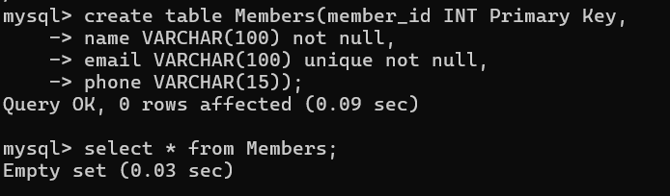

**---------------------------------------------------------------------------------------------------------**

**5. Write the SQL command to create a table Borrow_Records with:**

- record_id (Primary Key, INT)

- member_id (Foreign Key referencing Members)

- book_id (Foreign Key referencing Books)

- borrow_date (DATE)

- return_date (DATE)

**Ans:-**

mysql> create table Borrow_Records(record_id INT Primary Key,

-> member_id INT,

-> book_id INT,

-> borrow_date DATE not null,

-> return_date DATE,

-> FOREIGN KEY (member_id) REFERENCES Members(member_id),

-> FOREIGN KEY (book_id) REFERENCES Books(book_id)

-> );

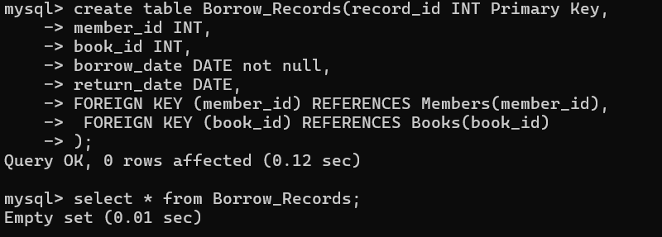

**-------------------------------------------------------------------------------------------------------**

**6. Modify the Books table to add a column genre of type VARCHAR(50).**

**Ans-**

mysql> alter table Books

-> add gentre VARCHAR(50);

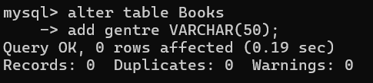

**---------------------------------------------------------------------------------------------------------**

**7. Write the SQL command to drop the Borrow_Records table.**

**Ans:-**

mysql> drop table Borrow_Records;

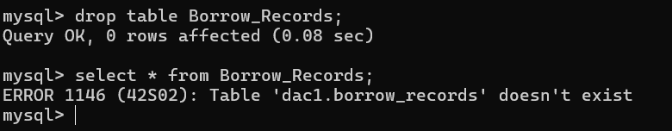

---------------------------------------------------------------------------------------------------------

**8. Insert 3 records into the Authors table.**

**Ans:-**

mysql> insert into Authors values(1,"R. K. Narayan","India");

mysql> insert into Authors values(2,"Paulo Coelho","Brazil");

mysql> insert into Authors values(3,"George Orwell","United Kingdom");

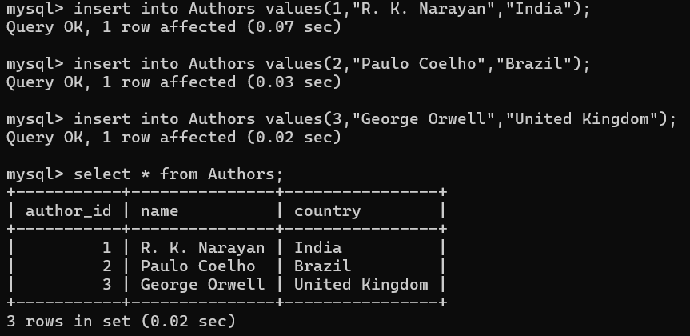

---------------------------------------------------------------------------------------------------------

**9. Insert 5 books into the Books table.**

**Ans:-**

**mysql>** INSERT INTO Books (book_id, title, author_id, published_year, available_copies) values

-> (1, 'The Great Gatsby', 1, 1925, 3);

**mysql>** INSERT INTO Books (book_id, title, author_id, published_year, available_copies,gentre) values

-> (2, 'To Kill a Mockingbird', 2, 1960, 5,'Historical Fiction');

**mysql>** INSERT INTO Books (book_id, title, author_id, published_year, available_copies,gentre) values

-> (3, 'Train to Pakistan', 3, 1949, 4,'Historical Drama');

**mysql>** INSERT INTO Books (book_id, title, author_id, published_year, available_copies,gentre) values

-> (4,"Brave New World",3,1932,2,"Social Fiction");

**mysql>** INSERT INTO Books (book_id, title, author_id, published_year, available_copies,gentre) values

-> (5,"Wings of Fire", 1, 1999, 1,"Autobiography");

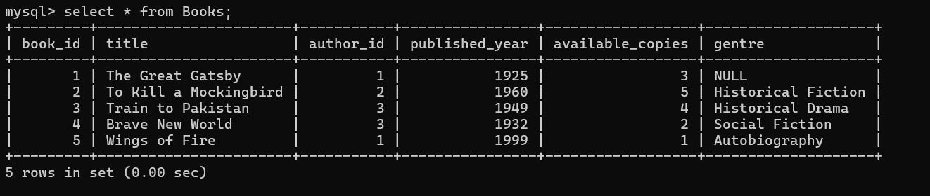

---------------------------------------------------------------------------------------------------------**10. Insert 3 members into the Members table.**

**Ans:-**

**mysql**> insert into Members values (1,"Darshana","dar@25gmail.com",8543215911);

**mysql>** insert into Members values (2,"Bhakti","bhakti@27gmail.com",8546321587);

**mysql>** insert into Members values (3,"Samiksha","sami@1gmail.com",8324567865);

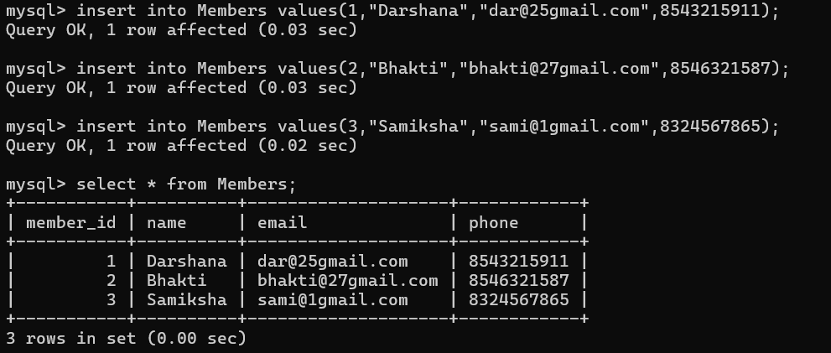

--------------------------------------------------------------------------------------------------------

**11. Insert 4 borrow records into the Borrow_Records table.**

**Ans:-**

**mysql>** insert into Borrow_Records values(1, 101, 1, '2025-09-01', '2025-09-10'),(2, 102, 3, '2025-09-05', '2025-09-15');

**mysql>** insert into Borrow_Records values(3, 103, 2, '2025-09-10', NULL),(4, 104, 5, '2025-09-12', '2025-09-22');

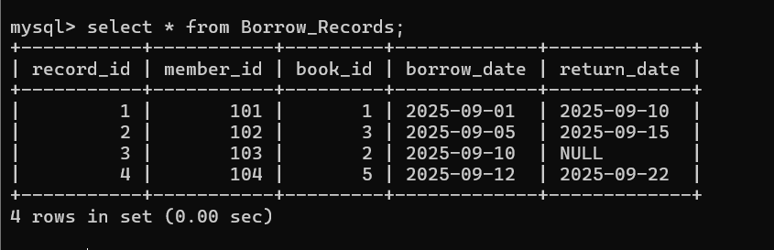

---------------------------------------------------------------------------------------------------------

**12. Write an SQL query to select all books where published_year is after 2015.**

**Ans:-**

**mysql>** select * from Books where published_year > 2015;

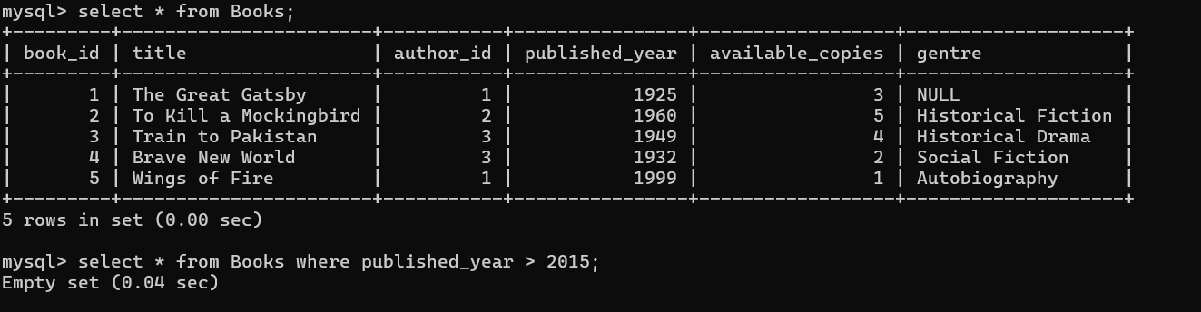

---------------------------------------------------------------------------------------------------------

**13. Write a SQL query to create a foreign key & primary key relationship between two tables.**

**Ans:-**

**mysql>** ALTER TABLE Books

-> ADD CONSTRAINT fk_author

-> FOREIGN KEY (author_id)

-> REFERENCES Authors(author_id);

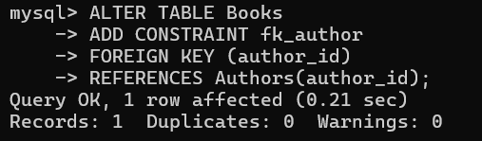

**---------------------------------------------------------------------------------------------------------**

**14. Write an SQL query to find all members who have borrowed the book with title 'Database Systems'.**

**Ans:-**

**mysql>** insert into Books values(6,"Database Systems",2,2000,1,"Coding");

**mysql>** select * from Books where title = "Database Systems";

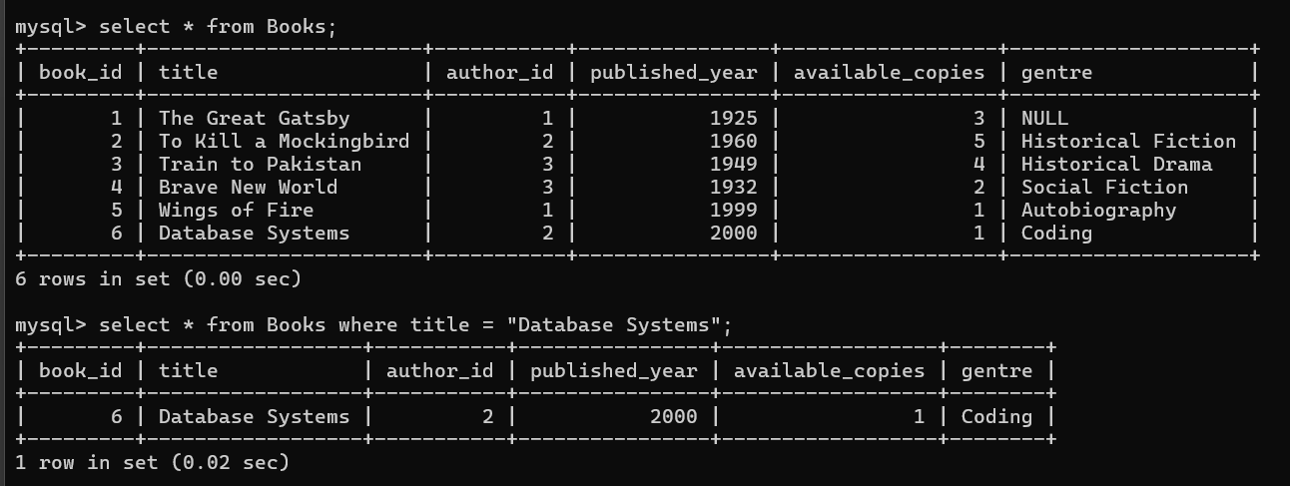

---------------------------------------------------------------------------------------------------------**15. Update the available_copies column of a specific book (choose any book) by reducing it by 1 after it is borrowed.**

**Ans:-**

mysql> update Books set available_copies = available_copies -1 where book_id= 3;

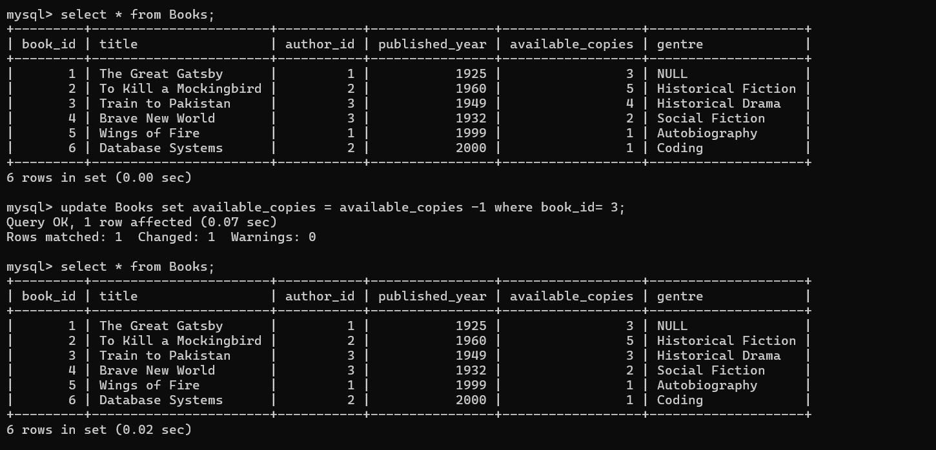

---------------------------------------------------------------------------------------------------------

**16. Delete a record from Members where member_id = 3.**

**Ans:-**

**mysql>** delete from Members where member_id = 3;

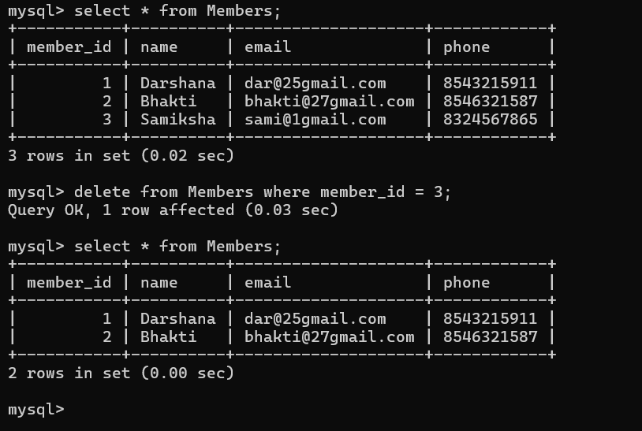

---------------------------------------------------------------------------------------------------------

**17. Update a Book name record from Book table with id = 1**.

**Ans:-**

**mysql>** update Books set title = "Moby Dick" where book_id = 1;

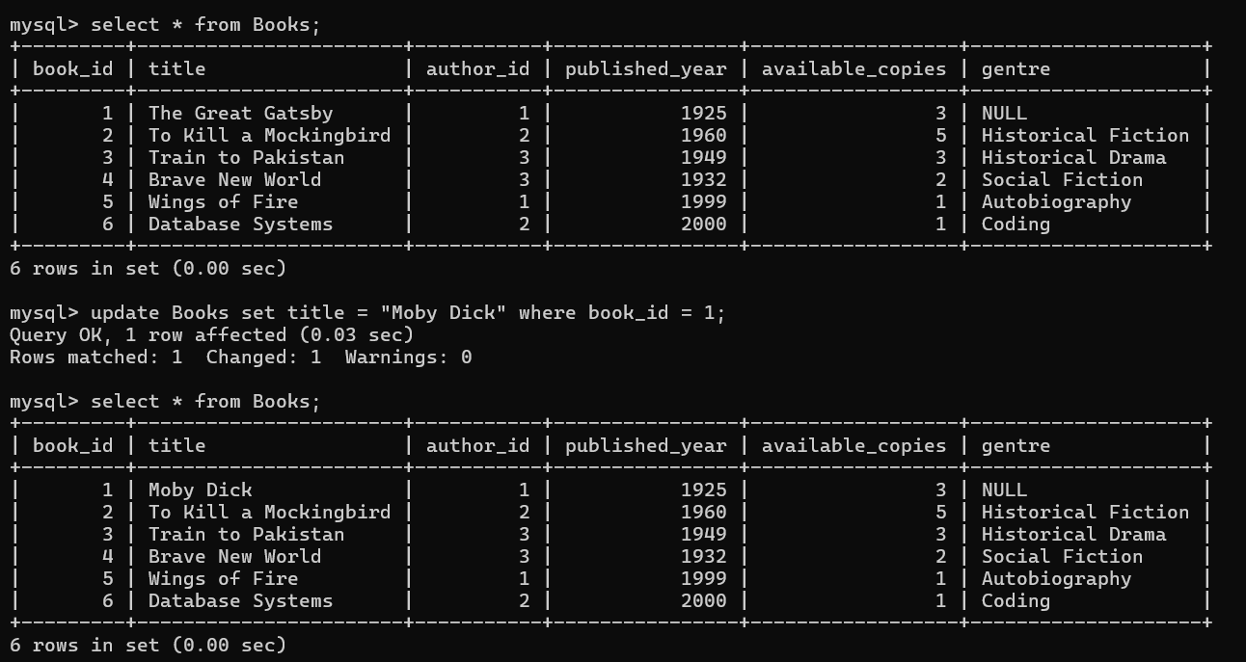

---------------------------------------------------------------------------------------------------------

**18. Write an SQL query to list all books along with their authors' names.**

**Ans:-**

mysql> SELECT

-> Books.book_id,

-> Books.title,

-> Authors.name AS author_name,

-> Books.gentre,

-> Books.published_year,

-> Books.available_copies

-> FROM

-> Books

-> INNER JOIN

-> Authors ON Books.author_id = Authors.author_id;

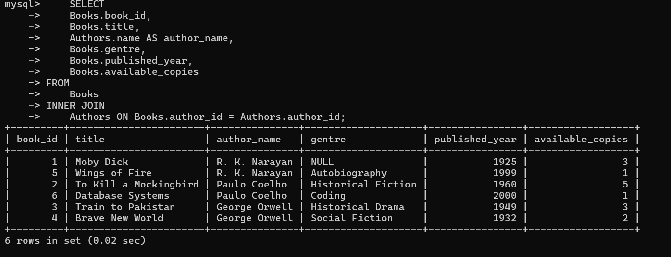

**---------------------------------------------------------------------------------------------------------**

**19. Write an SQL query to delete all books from the Books table where the published_year is before 2000.**

**Ans:-** mysql> delete from Books where published_year<2000;

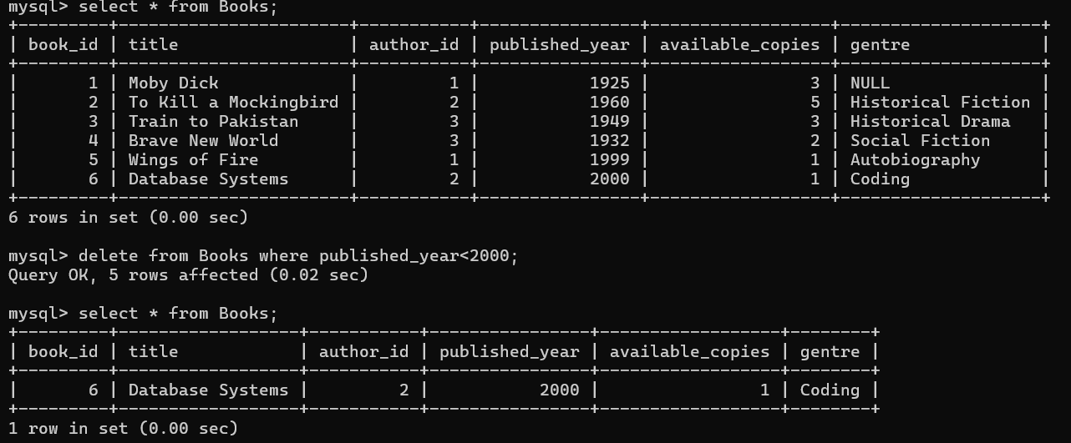

**--------------------------------------------------------------------------------------------------------**

**20. Write an SQL query to find all books that are never borrowed (i.e., no records in Borrow_Records).**

**Ans:-**

mysql> SELECT Books.book_id, Books.title, Books.author_id

-> FROM Books

-> LEFT JOIN Borrow_Records ON Books.book_id = Borrow_Records.book_id

-> WHERE Borrow_Records.book_id IS NULL;

